DSIP
Open Ended Problem – 2

92400133074
Dhananjay savsani
5EK1-c
Aim: Develop a program that performs audio convolution and inverse filtering to reduce or suppress background music in a given song using different impulse responses.
CODE:
import numpy as np
import matplotlib.pyplot as plt
import soundfile as sf
from scipy.signal import convolve
# Load audio file
audio, sample_rate = sf.read("song.wav")
# Convert stereo to mono
if len(audio.shape) == 2:
audio = np.mean(audio, axis=1)
print("Sample Rate =", sample_rate)
print("Total Samples =", len(audio))
# Three Impulse Responses
ir1 = np.array([1])
ir2 = np.array([1, 0.5])
ir3 = np.array([1, -1])
impulse_responses = [ir1, ir2, ir3]
# Plot original signal
plt.figure(figsize=(10,3))
plt.plot(audio)
plt.title("Original Audio")
plt.show()
# Apply each impulse response
for i in range(len(impulse_responses)):
print("\nProcessing IR", i + 1)
kernel = impulse_responses[i]
# Convolution
convoluted = convolve(audio, kernel, mode="same")
# Normalize
convoluted = convoluted / np.max(np.abs(convoluted))
# Save convoluted audio
sf.write("IR" + str(i+1) + "_Convolution.wav", convoluted, sample_rate)
# Simple inverse filter
inverse_kernel = kernel[::-1]
restored = convolve(convoluted, inverse_kernel, mode="same")
restored = restored / np.max(np.abs(restored))
# Save restored audio
sf.write("IR" + str(i+1) + "_Inverse.wav", restored, sample_rate)
# Plot graphs
plt.figure(figsize=(10,6))
plt.subplot(3,1,1)
plt.plot(audio)
plt.title("Original Audio")
plt.subplot(3,1,2)
plt.plot(convoluted)
plt.title("Convolution Output")
plt.subplot(3,1,3)
plt.plot(restored)
plt.title("Inverse Filter Output")
plt.tight_layout()
plt.show()
print("\nProgram Completed Successfully.")
OUTPUTS:
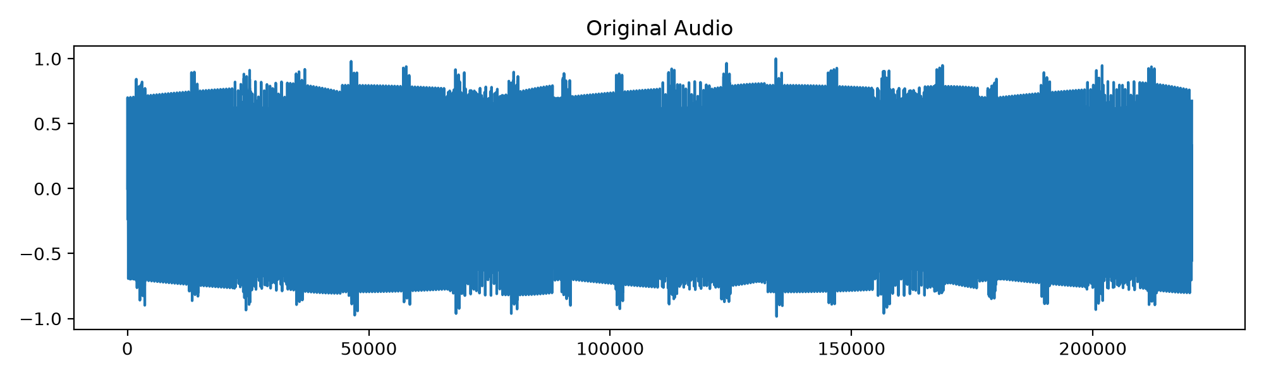
Impulse Response 1:
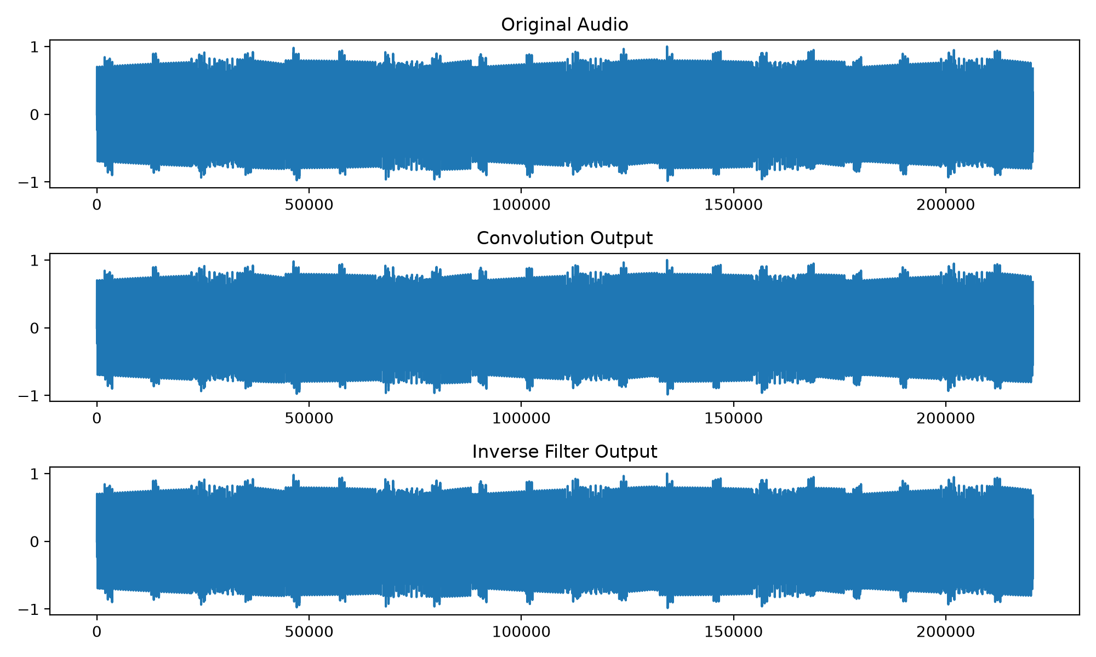
Observation: ir=[1]
Convolution:
The audio sounded almost the same as the original song. There was no noticeable change because the impulse response was [1].
Inverse Filtering:
The output was also almost the same as the original audio since there was no effect to remove.
Impulse Response 2:
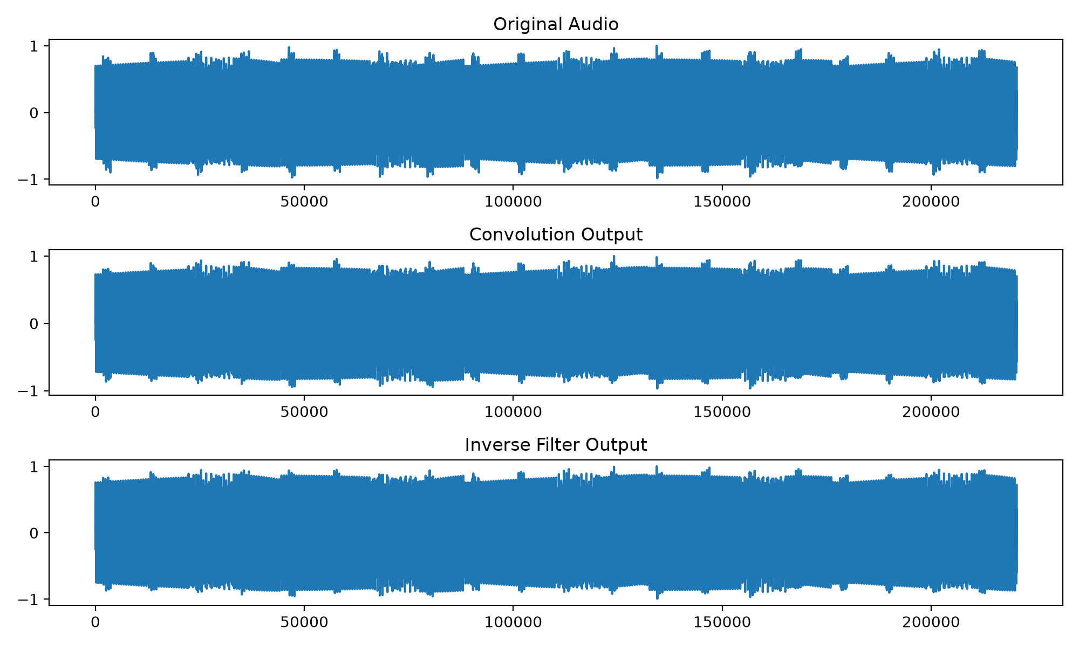
Observation: ir=[1, 0.5]
Convolution:
The audio had a slight echo and sounded a little smoother than the original. The background music was still present.
Inverse Filtering:
The echo effect was reduced, and the audio became closer to the original. However, the background music was not completely removed.
Impulse Response 3:
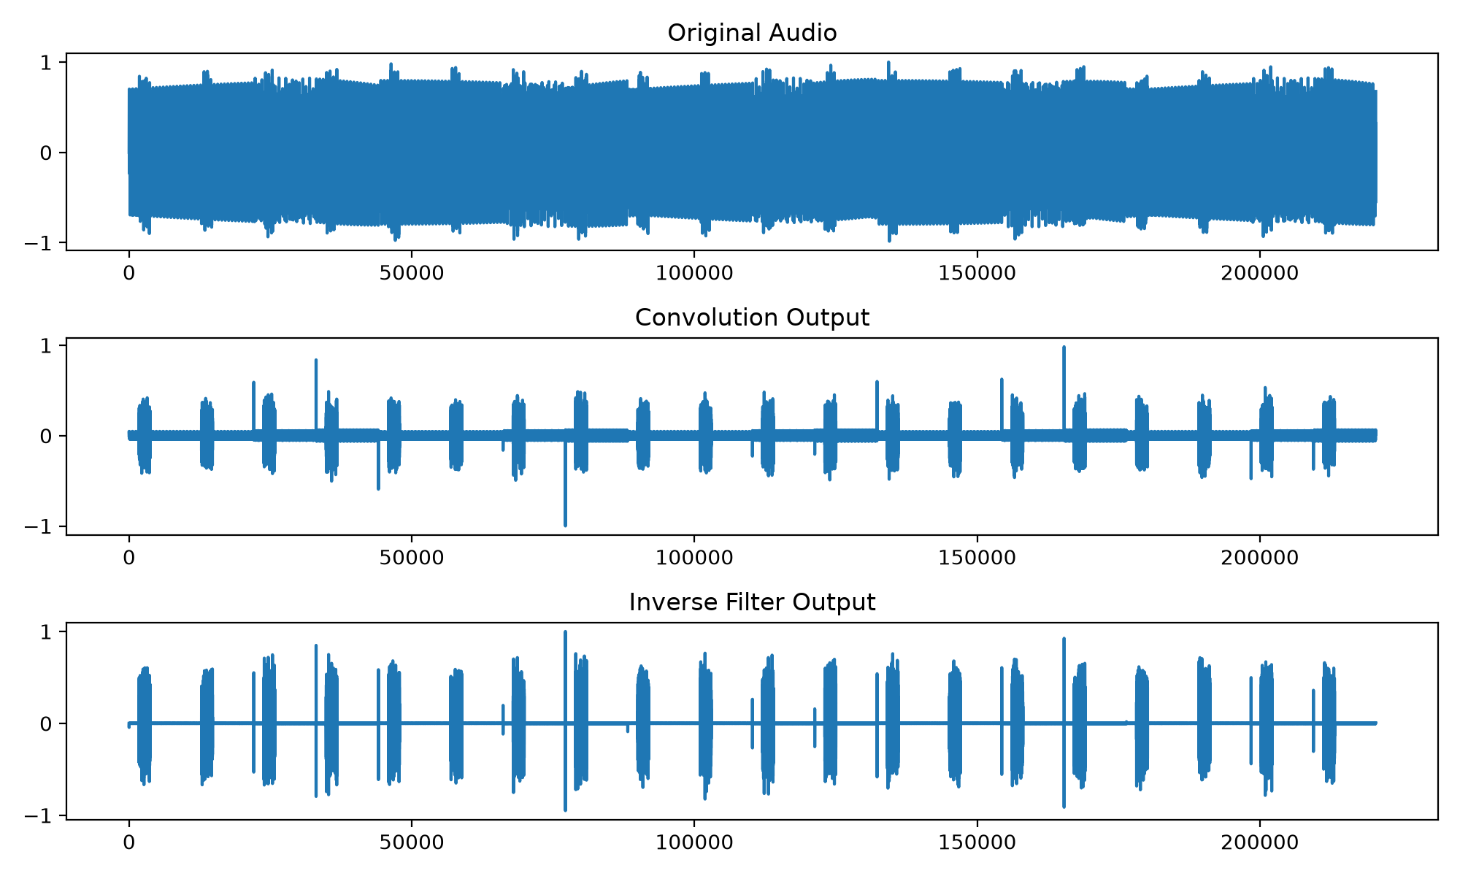
Observation: ir=[1, -1]
Convolution:
The audio sounded sharper, and some parts of the background music changed slightly. The waveform also looked different from the original.
Inverse Filtering:
The audio became more balanced after inverse filtering, but it was still not exactly the same as the original. Some background music was still present.
Conclusion:
Each impulse response changed the audio in a different way. IR1 produced almost no change, IR2 added a slight echo, and IR3 made the audio sharper. The inverse filtering process reduced some of these effects, but it could not completely remove the background music or perfectly restore the original audio.
Effectiveness:
Different impulse responses produced different changes in the audio signal. Inverse filtering improved the audio to some extent.
Limitations:
Background music was not completely removed.
The original audio could not be fully restored after inverse filtering.
The output depends on the impulse response used.

